**HOW TO setup Raspberry Pi as a TFTP Server**

[August 20, 2015](https://dynamicparallax.wordpress.com/2015/08/20/how-to-setup-raspberry-pi-as-a-tftp-server/) / [ineedchris](https://dynamicparallax.wordpress.com/author/ineedchris/)

Please **NOTE:** This document assumes that you already have Raspian OS installed and running on your Raspberry Pi.

[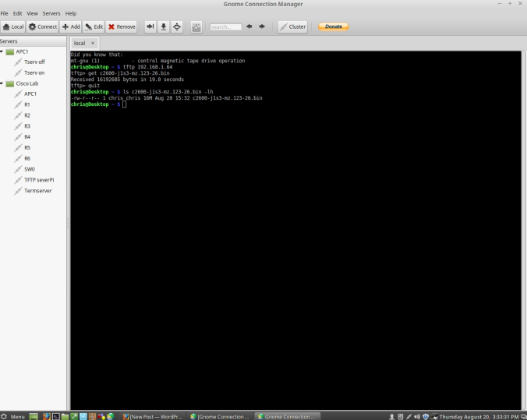](https://dynamicparallax.files.wordpress.com/2015/08/tftp-raspberry.jpg)

*— TFTP on the Pi is installed from a Terminal command line —*

# – *With your Raspberry Pi on your local network ssh into it and enter into root access.*

$ ssh pi@192.168.1.64

pi@raspberrypi ~ $ **sudo -s**

[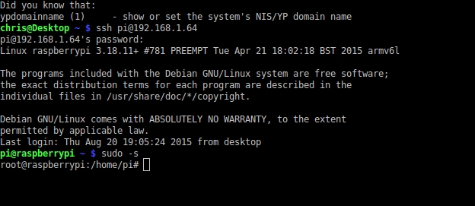](https://dynamicparallax.files.wordpress.com/2015/08/piaccess.jpg)

# – *After gaining ssh access to your Pi install the xinetd tftp package.*

root@raspberrypi:/home/pi# **apt-get install** **xinetd tftpd tftp**

*# – Create a file called /etc/xinet.d/tftp*

root@raspberrypi:/home/pi# **touch /etc/xinetd.d/tftp**

*# – Update your tftp file to include the tftp settings.*

root@raspberrypi:/home/pi# **nano /etc/xinetd.d/tftp**

— add the following lines to the tftp file —

service tftp

{

protocol = udp

port = 69

socket_type = dgram

wait = yes

user = nobody

server = /usr/sbin/in.tftpd

server_args = /tftpboot

disable = no

}

[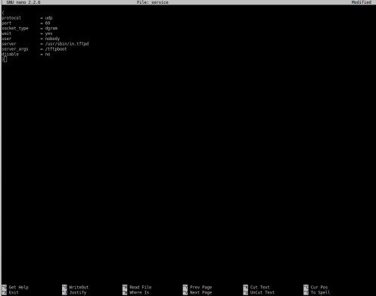](https://dynamicparallax.files.wordpress.com/2015/08/tftpfile.jpg)

*# – Save the file with shift+x and type Y to except changes*

*# – Make the directory you set in the tftp file on the Pi where you will store IOS images.*

root@raspberrypi:/home/pi#**mkdir /tftpboot**

*# – Make /tftpboot writable*

root@raspberrypi:/home/pi# **chmod -R 777 /tftpboot**

*# – Change ownership of tftp file*

root@raspberrypi:/home/pi# **chown -R nobody /tftpboot**

*# – Stop and start the xinetd service*

root@raspberrypi:/home/pi# **/etc/init.d/xinetd stop**

root@raspberrypi:/home/pi# **/etc/init.d/xinetd start**

*— Now we can test our tftp server —*

*# – Create a file on the server*

root@raspberrypi:/home/pi# **ls /> /tftpboot/test**

*# – Make the file writable*

root@raspberrypi:/home/pi# **chmod -R 777 /tftpboot**

*# – Verify file now exists*

root@raspberrypi:/home/pi# **ls /tftpboot/test -lh**

[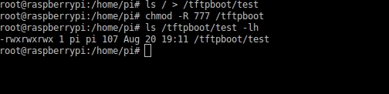](https://dynamicparallax.files.wordpress.com/2015/08/test.jpg)

*— Now we can move to our desktop and test the server —*

*# – Start tftp and connect to Raspberry Pi tftp*

$ **tftp 192.168.1.64**

*# – Get the test file*

tftp> **get test**

tftp> **quit**

*# – check that test file is now on Desktop.*

$ **ls test -ln**

[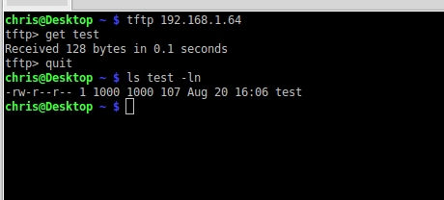](https://dynamicparallax.files.wordpress.com/2015/08/tesremote.jpg)